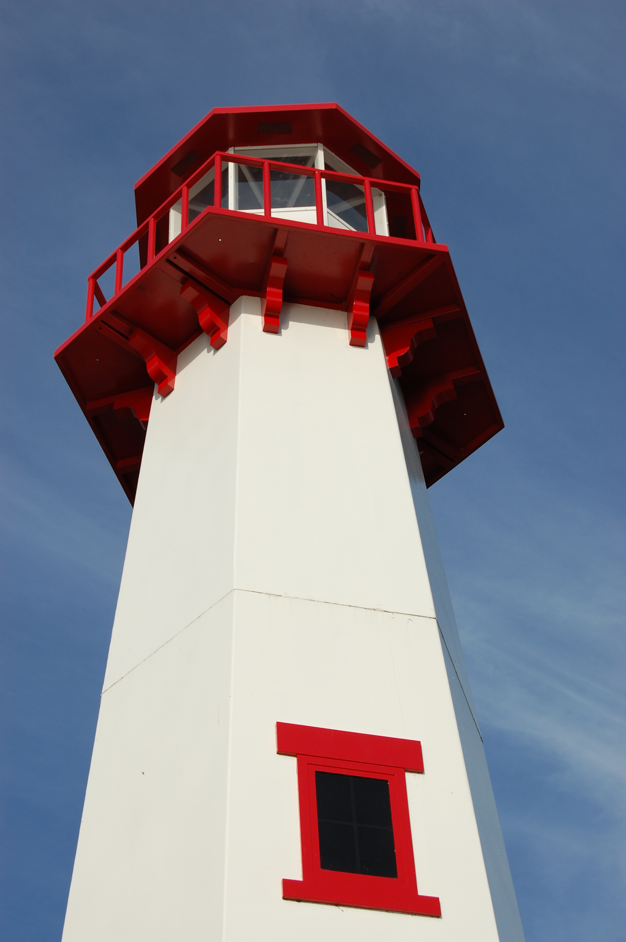
THE LIGHTHOUSE

Newsletter for August 2017

While I am in the world,
I am the light of the world.
John 9:5

Message from Our Pastor

Dear Sisters and Brothers in Christ,

It’s August!

Which means summer is at its peak, and I have been your pastor for two years now!! It’s been a wonderful two years and Catherine, Ellie and I are looking forward to many more years to come.

It’s been a busy summer. I went my first year here without performing a wedding. By the end of August, I will have done five already. I have done many hospital visits and have had plenty of just good conversations. It’s been a really good busy when it comes to being a pastor, and I wouldn’t have it any other way.

We have a couple of new things around here, a new gutter on the back of the church at Zion and a new porch on the parsonage founded by Trinity. Catherine and I are looking forward to hosting a couple of congregational BBQ’s so I will be announcing those dates very soon.

It’s also been a good time of reflection for me. Attendance which usually declines in the summer months has been really good, and I give thanks for that and pray that it continues and keeps on growing. It’s always wonderful when you get a phone call from Brevort saying “Pastor we need to print more bulletins” that’s music to my ears! The book studies at both churches have been going well and sparking some good conversation. Yes, it’s been a pretty good summer in the life of the church and for that I’m grateful.

Now, I want to say thank you. We have had some challenges in the last two years, but we walked through them together and for that I give thanks. We still have some challenges ahead of us, which is normal in the life of the church, but together we will prayerfully put them in God’s hands and ask the Holy Spirit to guide us through them and for that Thank You.

Blessings on the rest of your summer,

Yours in Christ,
Pastor David

Newsletter

The Newsletter was adopted


In honor of the marriage of
Molly Therrian & Gerritt Mortensen

by Grandma & Grandpa Soblaskey

Newsletter

The Newsletter was adopted by Jim & Jerri Rose


in Memory of
their granddaughter, Melissa Rose
&
Jerri’s sister, Kathryn Essary

Noisy Offering

The noisy offering for August 6th
will go to Project Backpack.

Vacation Bible School


Vacation Bible School will be held
from 6 – 8 pm at the United Methodist
Church from August 6th thru 9th.
We’re looking for volunteers, if you’re
interested contact Pastor David.

Adult Bible Study

Bible Study at Trinity will be Tuesdays at 6 pm.
Zion Bible Study will be on Wednesdays at 7 pm

Birthdays in August

Aug 2 Amber Anderson
Aug 2 Molly Dandona
Aug 5 Cierra Barker
Aug 6 Joe Chalmers
Aug 6 Bailey Ryerse
Aug 7 Sandy Feleppa
Aug 8 Ethan Shepard
Aug 8 Craig Therrian
Aug 11 Adrian Coleman
Aug 11 Chelsey Coleman
Aug 11 Madison Coleman
Aug 13 Tyler Chambers
Aug 14 Stephanie Jenkins
Aug 14 Lana Lennington
Aug 14 Dottie Glashaw
Aug 16 Cole Garen
Aug 17 Shari Baron
Aug 19 Haley Dodds
Aug 21 Matthew Rogers
Aug 22 Donovan Insley
Aug 23 Lisa Rogers
Aug 24 Nicole Garen
Aug 25 Kristine Vallier
Aug 26 Gary Sorenson
Aug 27 Les Therrian
Aug 28 Duane Gamble
Aug 29 Gunnar Olsen
Aug 30 Michael Gaubault
Aug 30 Jim Ryerse
Aug 31 Savannah Barker

Anniversaries in August

August 3 Mike & Janet Herman
August 6 Mark & Carol Elmblad
August 6 Michael & Faith Gaubault
August 17 Bob & Debbie Brandstrom
August 17 Jon & Connie Olsen
August 23 Durance & Becky Paul
August 28 Charlie & Audrey Stenson
August 28 Les & Debbie Therrian

Baptismal Anniversaries

August 1 Linda Wilkins

August 1 Dianne Nelson
August 10 Aubree Vallier
August 12 Debbie Therrian
August 18 Bob Brandstrom
August 18 Wendy McCluskey
August 20 Abby LaLonde

Trinity Worship Families

Aug 6 Gustafson Family
Aug 13 Movalson Family
Aug 20 Baron Family
Aug 27 Chalmers Family

Zion Funeral Committee July - September

Team Leader: Linda Wilkins (430-1465)
Co-leader: Lorraine Graham (643-8419)

Servants for Zion

Ushers & Greeters

Aug 6 Lorraine Graham & Marialana Nygard
Aug 13 Sandy & Fred Feleppa
Aug 20 Tim & Sally Idalski
Aug 27 Les & Debbie Therrian

Lectors

Aug 6 Betsy Turf
Aug 13 Loni LaVake
Aug 20 Paul Shepard
Aug 27 Dawn Akers

Communion Assistants

Aug 6 Lorraine Graham
Aug 13 Karen Schlehuber
Aug 20 Mary Christiansen
Aug 27 Steve Christiansen

Altar: Lorraine Graham
Money Counters: Susan Fenlon & Lorraine Graham

The Usher duties are:
- Arrive 30 minutes before church
- Put up song numbers from the bulletin
- Pass out bulletins and welcome guests
- Help with the offering and communion
- Record attendance

Council Meetings

Trinity Council – August 15, 6 pm
Zion Council – August 16, 6:30 pm

Zion’s Council Members
President: Steve Christiansen 298-1051
Vice-President Karen Schlehuber 643-0311
Co-Treasurers: Dawn Akers 643-7552
Co-Treasurers: Lana Lennington 643-6576
Secretary: Lorraine Graham 643-8419
Mary Christiansen 235-6123
Robert Marshall 643-8936
Dena Barker 430-1460
Paul Shepard 984-2069

Trinity’s Council Members
President: Jerri Rose 292-5570
Vice-President Sharon Chalmers 292-5440
Secretary: Tracy Movalson 292-5581
Treasurer: Pega Kennedy 292-5633
Co-Treasurer: Jim Rose 292-5570
Financial Secretary: Tom Gustafson 292-5460
WELCA: Pega Kennedy 292-5633
John Kennedy 292-5633
Lois Movalson 292-5581

Treasurer's Report for Zion
January 1, 2017 through July 15, 2017
Income:
 | Amazon Smile Foundation | 44.03
 | Building | $ 75.00
 | Church Use Income | $ 940.00
 | General | $ 29,500.21
 | Fund Raising - Soup Luncheon | $ 1,518.90
 | Thrivent Financial Income | $ 446.00
 | Trinity Share | $ 7,962.46
 | TOTAL |  | $ 40,486.60
Expenses:
 | Administration | $ 1,898.99
 | Benevolence | $ 971.89
 | Church Maintenance | $ 7,326.19
 | Education | $ 342.40
 | Parsonage Maintenance | $ 1,911.12
 | Pastoral | $ 27,167.31
 | Worship | $ 2,116.97
 | --To Building Fund | $ 0.00
 |  |  | $ 41,734.87
 |  |  | -1,248.27
***********************************************************
Thrivent Financial Investment Fund |  |  | $ 288.07
General fund balance: |  |  | $ (625.33)
Kitchen/Building Fund balance |  |  | $ 1,406.63
General fund owes building fund: |  |  | $ 75.00
General fund owes Mission Endowment fund: |  |  | $ 7,995.00

Contact Information

Pastor David Tielbar may be reached at 906-984-2051 or at david.tielbar6@gmail.com. In an emergency, you can reach the Pastor’s cell phone at (563) 880-4512

Church telephone: 906-643-7870 - Answering machine
The secretary will usually be in the office on Tuesday and Thursday mornings from 9 – 12

To email the church is: ziontrinity950@yahoo.com
The website is at http://zionstignace.com/home.html
- Find us on facebook at www.facebook.com/zionstignace

Zion Evangelical Lutheran Church and Trinity Lutheran Church are congregations of the Northern Great Lakes Synod and the Evangelical Lutheran Church in America.

Trinity’s Sunday Service is at 9 a.m.
Zion’s Sunday Service is at 11 a.m.

Blast to the Past


The Diane Peppler Resource Center Presents “Blast to the Past” - Livin’ in the 80’s

5K Race, 1 Mile Fun Run, Costume Contest
August 26 @ 6 pm
American Legion Memorial Park
St. Ignace, Michigan

Register on-line at www.dprcenter.org on our Calendar for August.

Prayer List

(If you would like someone added to the prayer list, email or call the church)


Mary Belonga, Dave & Lois Movalson, LaTaunya Paquin, Barb Lehto, Bev Kammers, Joe Chalmers, Nadine Dandona, Patty Thibault, Karen Fowler, Delores Marshall, Bill & Sandy Tielbar, Walter & Jane Puccio, Linda Wilkins, Bill Anderson, Karen Kammers Sparks, Joel Morabito, Rick Brown, Eric Rose, Jackie Kallstrom, Russell Winberg, Tom & Taffy Coffey, Charlie Doud, Richard Galor, Sarah Marolf, Eunice Therrian, Wes Pechta, Lou Hitts, Jack Dyer, Fred Dandona, Rick Weiss, Toni Leny, Judy Ryerse, Mandy Jones, Carol Watson, Bea Zak, Judy Schlehuber Bridges, Aiden, Rodney Novenske, John Lata, Jody Gustafson, Linda Kendall Weiss, Gaven Gustafson, Owen, Bernie, and all of our homebound & in long term care

Pastor on Vacation

Pastor David and Family will be gone on vacation from August 23rd – September 1st. Mike Herman will fill in on August 27th.

HOPE Chest

The new summer HOPE Chest hours are:
Fri - Mon: Closed
Tues - Thurs: 10 am – 4 pm

